



|  |
| --- |
| **PR Activity - September 2021** |

**PR Activity September 2021**

|  |
| --- |
| **Highlights of the month:**   1. We have received total 61 coverages- 23 print, 38 online. 2. We have received, 16 SIPM coverage, 26 Suguna Foods, and 19 Suguna Daily Fressh coverage in total. 3. The press release on the topic “Suguna Institute of Poultry Management ties up with the government of India New Delhi” was carried across publications pan India. 4. The press release on the topic “Suguna Daily Fressh expands its footprints in South India with 250 + stores” was carried across publications pan India. 5. The Press Release on the topic, “Suguna Feeds launches Cattle feed at affordable prices.” 6. The press release on Cattle feed launch has garnered trade magazine coverage. |

**Name of the Media:** Jagruk

**Date:** 17.09.2021

**Region**: Maharashtra

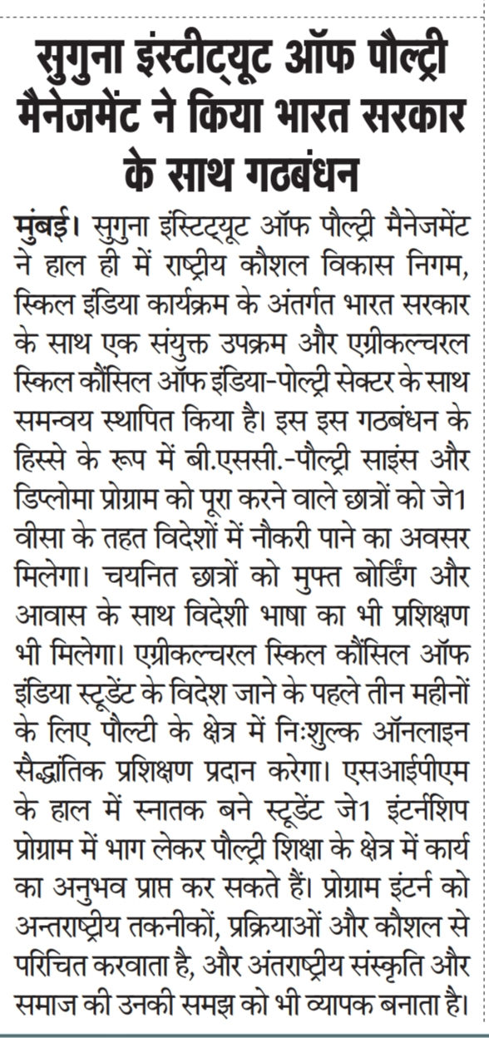

**Name of the Media:** Uttar Shakthi

**Date:** 17.09.2021

**Region**: Maharashtra



**Name of the Media:** Deshbandhu

**Date:** 18.09.2021

**Region**: New Delhi

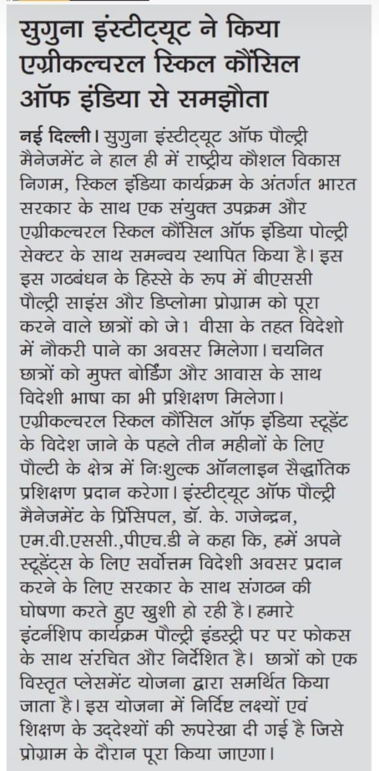

**Name of the Media:** Vanakam Thamizhagam

**Date:** 19.09.2021

**Region**: Tamil Nadu

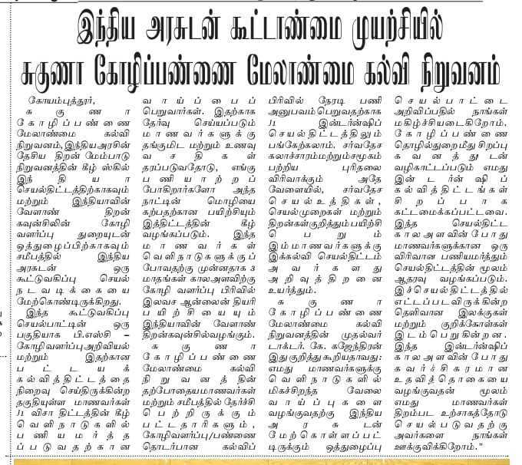

**Name of the Media:** The Global Times

**Date:** 20.09.2021

**Region**: Maharashtra

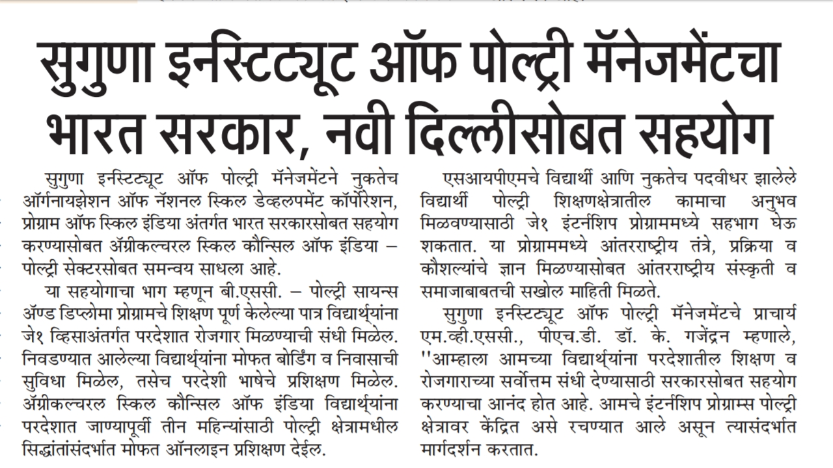

**Name of the Media:** The Hindu

**Date:** 20.09.2021

**Region**: Tamil Nadu



**Name of the Media:** Amrit India

**Date:** 22.09.2021

**Region**: 22.09.2021

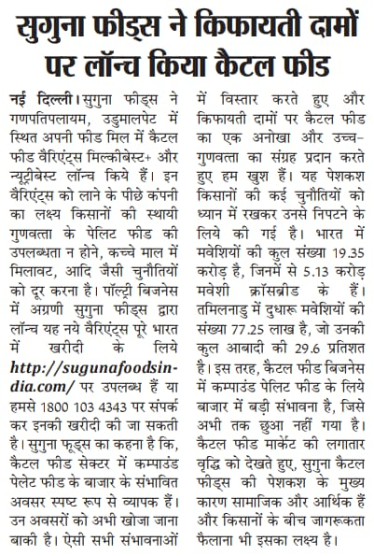

**Name of the Media:** Shah TImes

**Date:** 22.09.2021

**Region**: Maharashtra

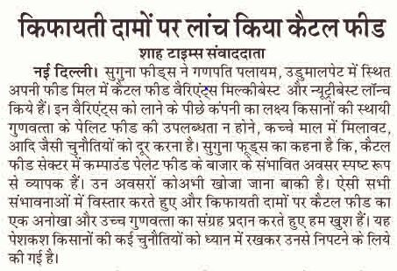

**Name of the Media:** Shivner

**Date:** 22.09.2021

**Region**: Maharashtra

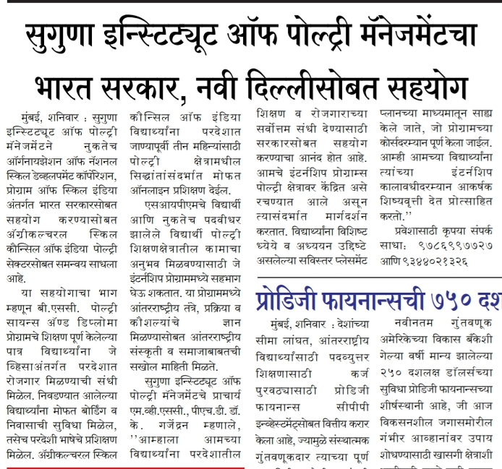

**Name of the Media:** Uttar Prahari

**Date:** 22.09.2021

**Region**: Maharashtra

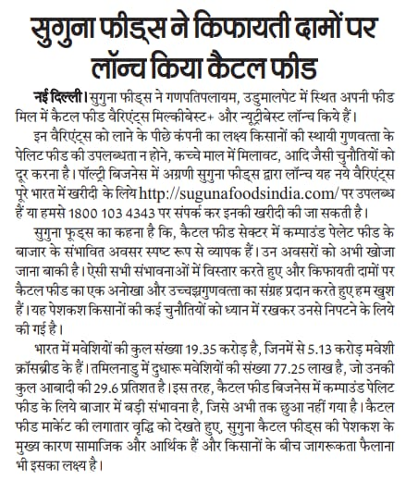

**Name of the Media:** Jagruk TImes

**Date:** 23.09.2021

**Region**: Maharashtra

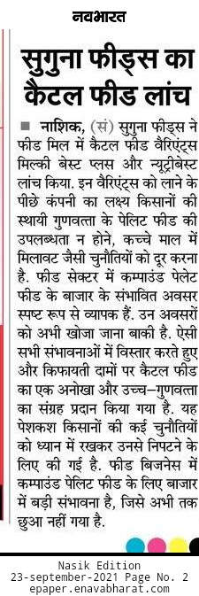

**Name of the Media:** Subashistha

**Date:** 23.09.2021

**Region**: Karnataka

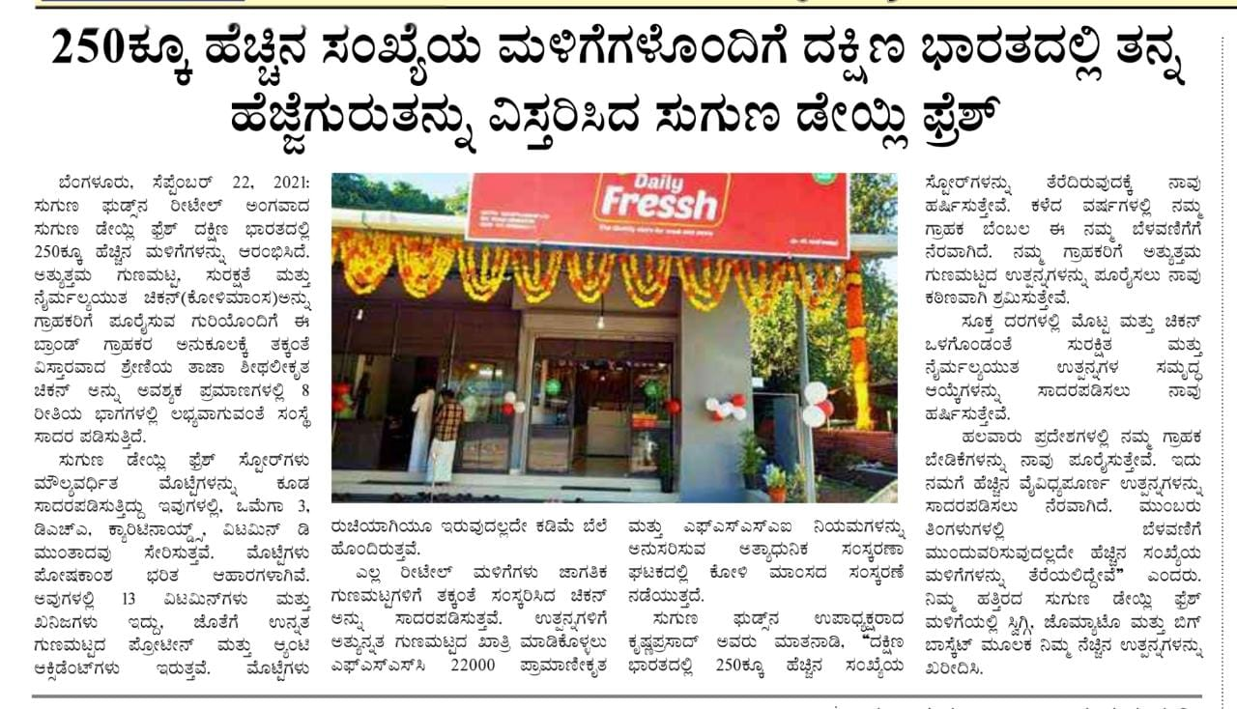

**Name of the Media:** Navbharath

**Date:** 23.09.2021

**Region**: Maharashtra

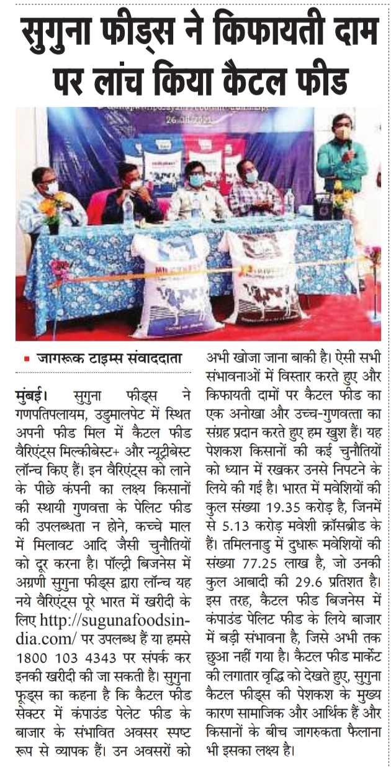

**Name of the Media:** Udhayavani

**Date:** 23.09.2021

**Region**: Karnataka



**Name of the Media:** The Global Times

**Date:** 24.09.2021

**Region**: Maharashtra

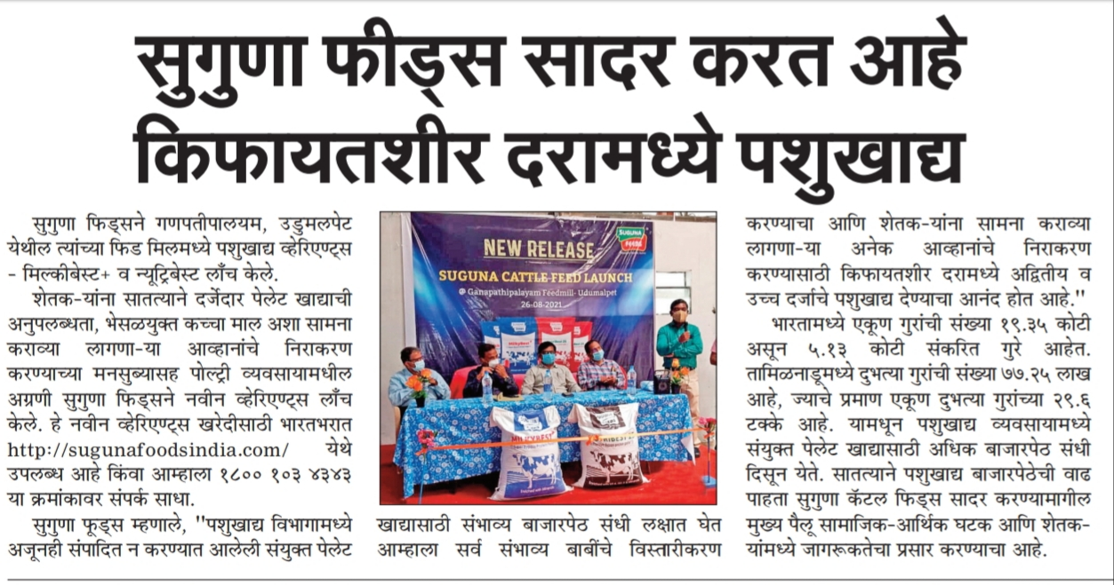

**Name of the Media:** Shubrabadam

**Date:** 27.09.2021

**Region**: Kerala

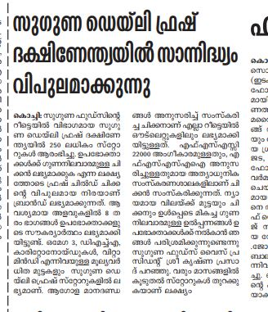

**Name of the Media:** Madhyamam

**Date:** 27.09.2021

**Region**: Kerala

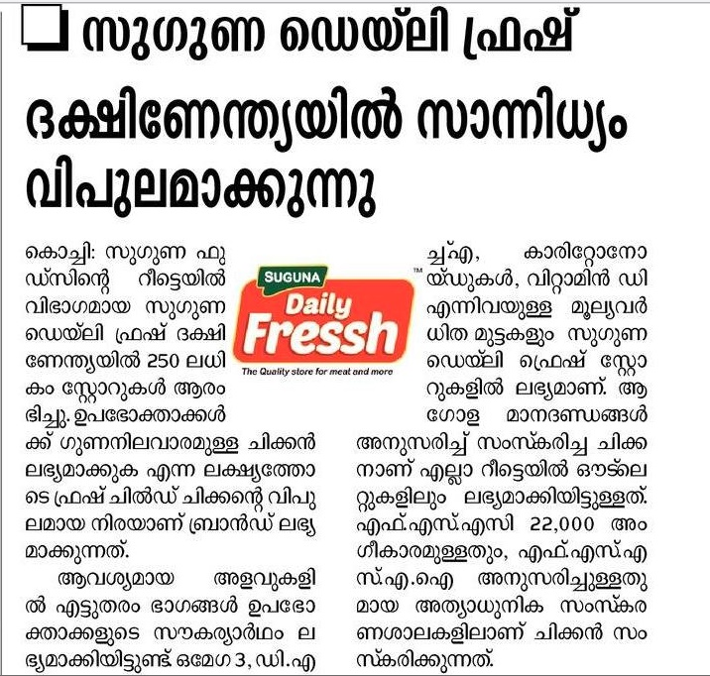

**Name of the Media:** Malayalam Manorama

**Date:** 27.09.2021

**Region**: Kerala



**Name of the Media:** Kalakamaudi

**Date:** 27.09.2021

**Region**: Kerala

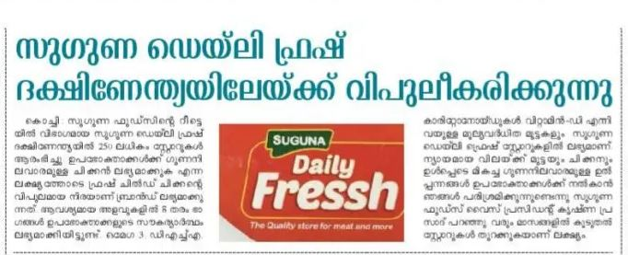

**Name of the Media:** Deepika

**Date:** 28.09.2021

**Region**: Kerala

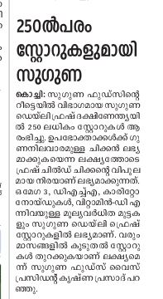

**Name of the Media:** Metro Vartha

**Date:** 29.09.2021

**Region**: Kerala

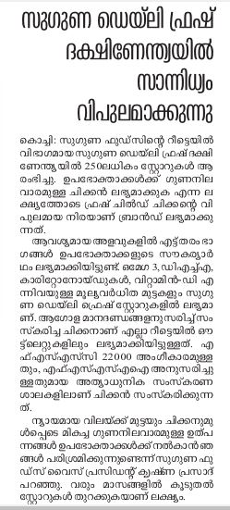

**Name of the Media:** Veekshanam

**Date:** 29.09.2021

**Region**: Kerala



**Name of the Media:** Kerala Kaumudi

**Date:** 30.09.2021

**Region**: Kerala

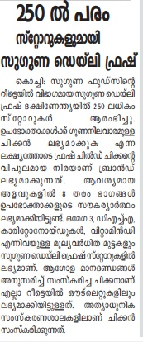

**Online Coverage:**

|  |  |  |  |  |
| --- | --- | --- | --- | --- |
| 1 | 19.09.2021 | India Education Diary | Suguna Institute of Poultry Management ties up with Government of India, New Delhi | https://indiaeducationdiary.in/suguna-institute-of-poultry-management-ties-up-with-government-of-india-new-delhi/ |
| 2 | 20.09.2021 | APN News | Suguna Institute of Poultry Management ties up with Government of India, New Delhi | https://www.apnnews.com/suguna-institute-of-poultry-management-ties-up-with-government-of-india-new-delhi/ |
| 3 | 20.09.2021 | Republic News India | Suguna Institute of Poultry Management ties up with Government of India, New Delhi | https://republicnewsindia.com/suguna-institute-of-poultry-management-ties-up-with-the-government-of-india-new-delhi/ |
| 4 | 20.09.2021 | India Scoops | Suguna Institute of Poultry Management ties up with Government of India, New Delhi | https://indianscoops.com/suguna-institute-of-poultry-management-ties-up-with-the-government-of-india-new-delhi/ |
| 5 | 20.09.2021 | Hindustan Saga | Suguna Institute of Poultry Management ties up with Government of India, New Delhi | https://hindustansaga.com/suguna-institute-of-poultry-management-ties-up-with-the-government-of-india-new-delhi/ |
| 6 | 20.09.2021 | RD times | Suguna Institute of Poultry Management ties up with Government of India, New Delhi | https://rdtimes.in/suguna-institute-of-poultry-management-ties-up-with-the-government-of-india-new-delhi/ |
| 7 | 20.09.2021 | Edu RD times | Suguna Institute of Poultry Management ties up with Government of India, New Delhi | https://edu.rdtimes.in/suguna-institute-of-poultry-management-ties-up-with-the-government-of-india-new-delhi/ |
| 8 | 20.09.2021 | Digital Media 9 | Suguna Institute of Poultry Management ties up with Government of India, New Delhi | https://digitalmedia9.com/business/suguna-institute-of-poultry-management-ties-up-with-government-of-india-new-delhi/ |
| 9 | 20.09.2021 | Business News this week | Suguna Institute of Poultry Management ties up with Government of India, New Delhi | http://businessnewsthisweek.com/business/suguna-institute-of-poultry-management-ties-up-with-government-of-india-new-delhi/ |
| 10 | 20.09.2021 | Pashudhan Praharee | Suguna Feeds Launches cattle feed at affordable prices | http://www.pashudhanpraharee.com/suguna-feeds-launches-cattle-feed-at-affordable-price/ |
| 11 | 21.09.2021 | Indian news | Suguna Daily Fressh expands its footprint in south India with 250 stores | https://indiannewz.wordpress.com/2021/09/20/suguna-daily-fressh-expands-its-footprints-in-south-india-with-250stores/ |
| 12 | 21.09.2021 | City air news | Suguna Daily Fressh expands its footprint in south India with 250 stores | <https://www.cityairnews.com/content/suguna-daily-fressh-expands-its-footprints-in-south-india-with-250-plus-stores> |
| 13 | 21.09.2021 | Business news this week | Suguna Feeds Launches cattle feed at affordable prices | http://businessnewsthisweek.com/business/suguna-feeds-launches-cattle-feed-at-affordable-price/ |
| 14 | 21.09.2021 | Media bulletins | Suguna Feeds Launches cattle feed at affordable prices | http://mediabulletins.com/business/suguna-feeds-launches-cattle-feed-at-affordable-price/ |
| 15 | 21.09.2021 | Content media solutions | Suguna Feeds Launches cattle feed at affordable prices | https://contentmediasolution.com/business/suguna-feeds-launches-cattle-feed-at-affordable-price/ |
| 16 | 21.09.2021 | Online media café | Suguna Feeds Launches cattle feed at affordable prices | https://onlinemediacafe.com/business/suguna-feeds-launches-cattle-feed-at-affordable-price/ |
| 17 | 21.09.2021 | Digital media 9 | Suguna Feeds Launches cattle feed at affordable prices | https://digitalmedia9.com/business/suguna-feeds-launches-cattle-feed-at-affordable-price/ |
| 18 | 21.09.2021 | Digital media 9 | Suguna Daily Fressh expands its footprint in south India with 250 stores | https://digitalmedia9.com/business/suguna-daily-fressh-expands-its-footprints-in-south-india-with-250stores/ |
| 19 | 21.09.2021 | Business news this week | Suguna Daily Fressh expands its footprint in south India with 250 stores | http://businessnewsthisweek.com/business/suguna-daily-fressh-expands-its-footprints-in-south-india-with-250stores/ |
| 20 | 21.09.2021 | Business news this week fb | Suguna Daily Fressh expands its footprint in south India with 250 stores | <https://www.facebook.com/BusinessNewsThisWeek/posts/224198386392523> |
| 21 | 21.09.2021 | Business news this weel linkedin | Suguna Daily Fressh expands its footprint in south India with 250 stores | https://www.linkedin.com/feed/update/urn:li:activity:6845956175771631617 |
| 22 | 21.09.2021 | Business news this week | Suguna Feeds Launches cattle feed at affordable prices | http://businessnewsthisweek.com/business/suguna-feeds-launches-cattle-feed-at-affordable-price/ |
| 23 | 21.09.2021 | Media bulletins | Suguna Feeds Launches cattle feed at affordable prices | http://mediabulletins.com/business/suguna-feeds-launches-cattle-feed-at-affordable-price/ |
| 24 | 21.09.2021 | Content media solutions | Suguna Feeds Launches cattle feed at affordable prices | https://contentmediasolution.com/business/suguna-feeds-launches-cattle-feed-at-affordable-price/ |
| 25 | 21.09.2021 | Online media café | Suguna Feeds Launches cattle feed at affordable prices | https://onlinemediacafe.com/business/suguna-feeds-launches-cattle-feed-at-affordable-price/ |
| 26 | 21.09.2021 | Digital media 9 | Suguna Feeds Launches cattle feed at affordable prices | https://digitalmedia9.com/business/suguna-feeds-launches-cattle-feed-at-affordable-price/ |
| 27 | 21.09.2021 |  | Suguna Feeds Launches cattle feed at affordable prices | https://twitter.com/neel5/status/1440219589007187968 |
| 28 | 21.09.2021 | Business News this week | Suguna Feeds Launches cattle feed at affordable prices | https://www.linkedin.com/posts/business-news-this-week_suguna-feeds-launches-cattle-feed-at-affordable-activity-6845987066828873729-dDlC |
| 29 | 21.09.2021 | PNI News | Suguna Feeds Launches cattle feed at affordable prices | https://www.pninews.com/suguna-feeds-launches-cattle-feed-at-affordable-price/ |
| 30 | 21.09.2021 | Apensha Sandesh | Suguna Institute of Poultry Management ties up with Government of India, New Delhi | https://apekshasandesh.com/suguna-institute-of-poultry-management-ties-up-with-government-of-india-new-delhi |
| 31 | 21.09.2021 | Apensha Sandesh | Suguna Daily Fressh expands its footprint in south India with 250 stores | <https://apekshasandesh.com/suguna-daily-fressh-expands-its-footprints-in-south-india-with-250stores> |
| 32 | 21.09.2021 | Republic News India | Suguna Feeds Launches cattle feed at affordable prices | https://republicnewsindia.com/suguna-feeds-launches-cattle-feed-at-affordable-price/ |
| 33 | 21.09.2021 | India Scoops | Suguna Feeds Launches cattle feed at affordable prices | https://indianscoops.com/suguna-feeds-launches-cattle-feed-at-affordable-price/ |
| 34 | 21.09.2021 | Biz RD times | Suguna Feeds Launches cattle feed at affordable prices | https://biz.rdtimes.in/suguna-feeds-launches-cattle-feed-at-affordable-price/ |
| 35 | 21.09.2021 | APN News | Suguna Feeds Launches cattle feed at affordable prices | https://www.apnnews.com/suguna-feeds-launches-cattle-feed-at-affordable-price/ |
| 36 | 28.09.2021 | Pelikken | Suguna Daily Fressh expands its footprint in south India with 250 stores | <https://pelikken.com/single/news/3436> |
| 37 | 28.09.2021 | News Experts | Suguna Daily Fressh expands its footprint in south India with 250 stores | http://www.newsexperts.in/suguna-daily-fressh-expands-its-footprints-in-south-india-with-250stores/ |
| 38 | 28.09.2021 | Business on live | Suguna Daily Fressh expands its footprint in south India with 250 stores | https://www.businessonlive.com/shopping/71303?amp=1 |